1. 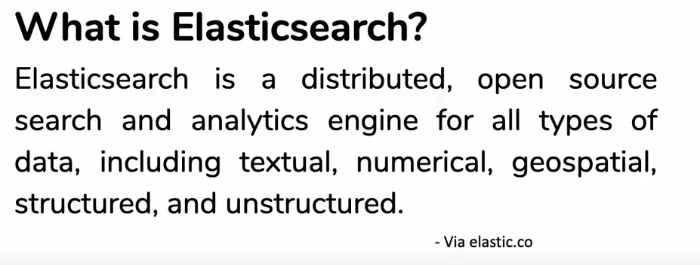
2. Based on Apache Lucene and first released in 2010.
3. Central component of elastic stack (A set of open source tools).
4. **Stack**: A set of open source tools for
   1. Data ingestion, enhancement, storage analysis and visualization.
5. It’s known for its Simple RESTful API, distributed nature speed and scalability.
6. It’s commonly referred to as the ELK Stack (Elasticsearch, LogStash, Kibana).
7. **Elasticsearch**:
   1. It is a database that stores, retrieve, manages document oriented and semi-structure data. Data is stored in JSON format and then we query for it.
8. 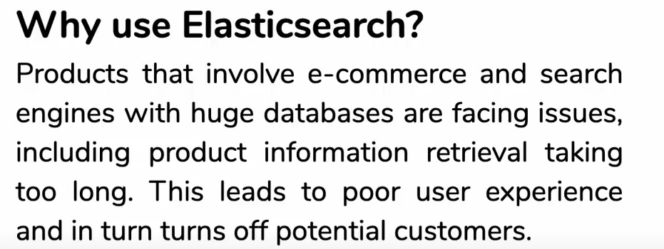
9. 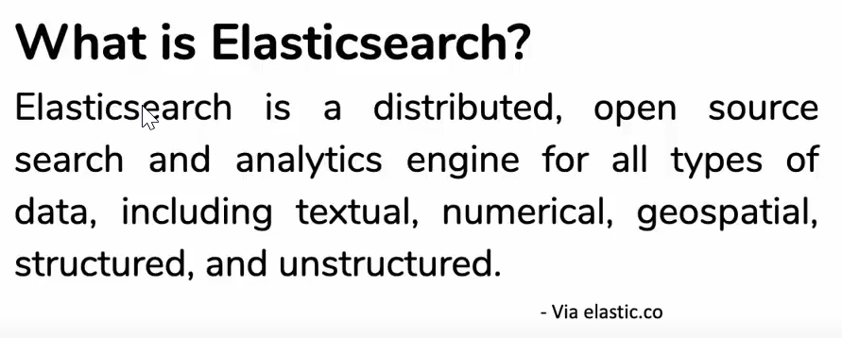
10. 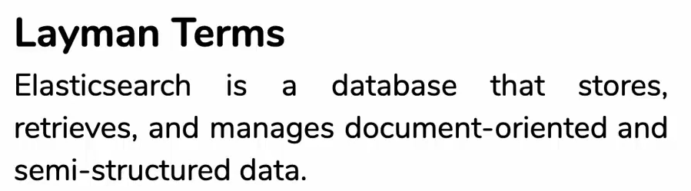
11. 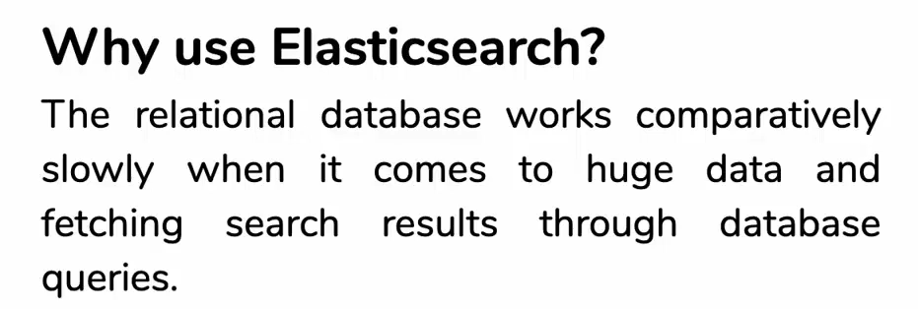
12. 